**Eagle Flight**

Members: Yaowu Huang, Ying Hao, Zhiwei Li

Date: June 02, 2021

**Description**

This project is to develop a website of flight/user management system for Eagle Flight. Client could register account and book ticket on-line, and Eagle Flight can plan and adapt flights. The back-end part is built on ASP.NET and Sqllite. Regarding front end, HTML, CSS and javascript are the necessary technologies to support sufficient functionalities.

**Special Features**

* /(index): welcome page to show searching and login/register info.
* /register: to register account
* /login: user login
* /logout: user logout
* /profile: user edit on profile
* /flights: to view details of each flight (filtered search result)
* /booking: to book flight (limited time to lock the ticket before payment done)
* /bill: summary of the ticket bill
* /pay: to pay the order by client
* /admin/user : manage users (add, activate, de-activate, reset password, isadmin, …)
* /admin/flight: manage flight (add, edit, cancel-> ticket cancellation / balance change)
* /admin/boarding: to book seat for passengers

**Technologies**

* ASP.NET (session, security, upload image/files like ID, etc.)
* JavaScript (Jquery, Ajax)
* Bootstrap

**Additional Libraries**

* EntityFramework Core
* Razor
* Sqlite

**Challenges**

* Customize IdentityUser for passengers
* Jquery Validation
* REST API by C#
* CRUD on tables with foreign keys
* Payment gateway integration
* Production deployment of ASP.NET

**Database**

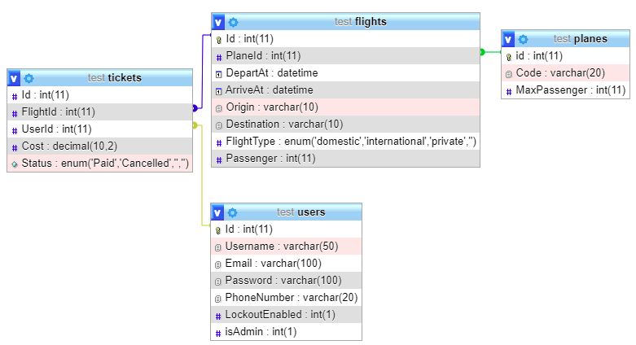

**Mock-up:**

* 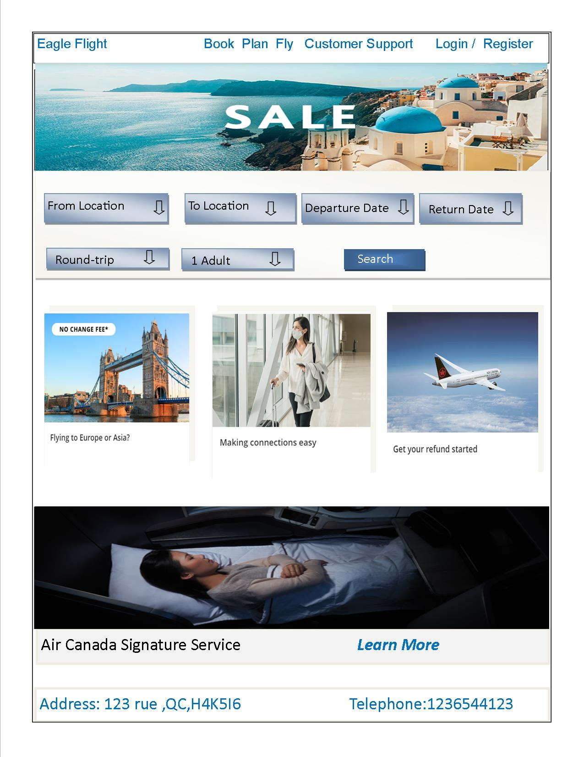**Main page**
* 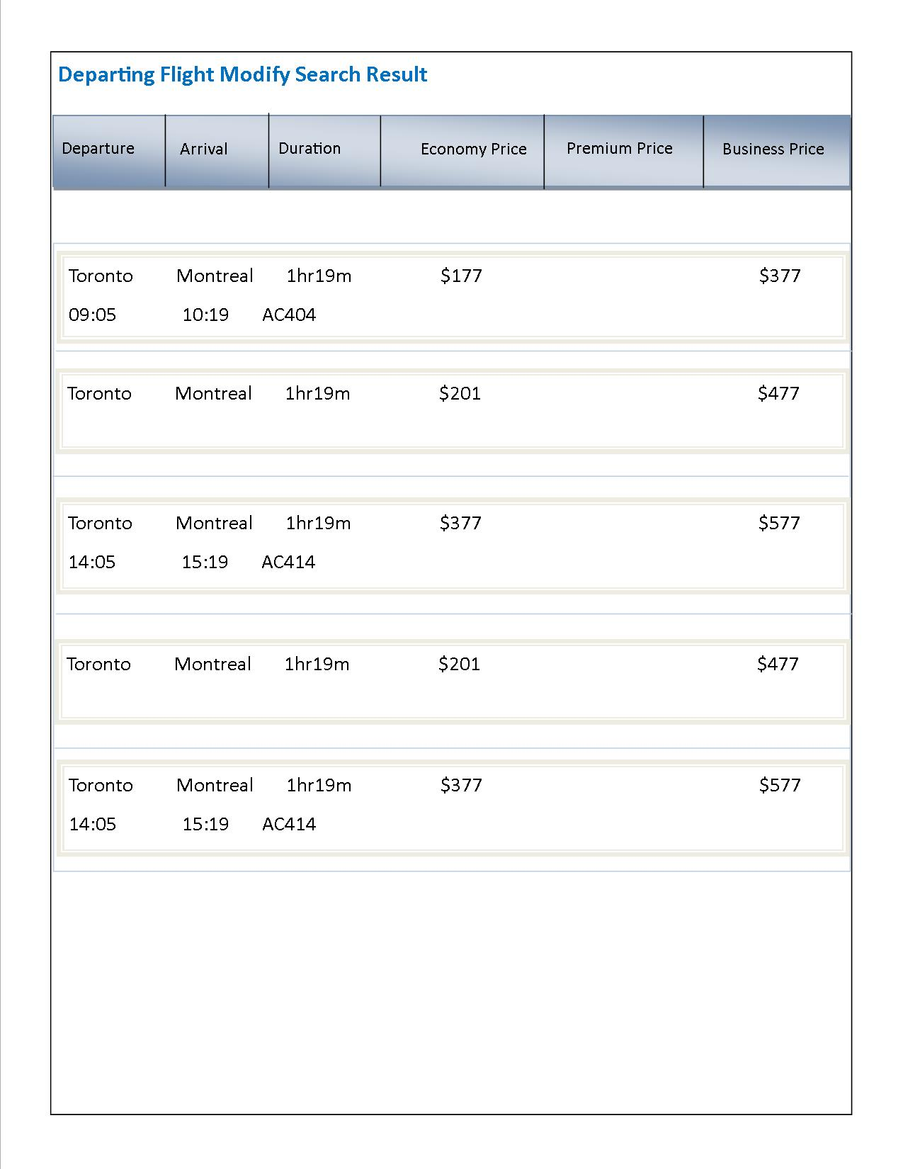**Flights Search Page**
* **Confirmation Page**

